Write a code in cpp swapping two  value

Use Reference

Pass by value

Pass by refernce

/\*\*\*\*\*\*\*\*\*\*\*\*\*\*\*\*\*\*\*\*\*\*\*\*\*\*\*\*\*\*\*\*\*\*\*\*\*\*\*\*\*\*\*\*\*\*\*\*\*\*\*\*\*\*\*\*\*\*\*\*\*\*\*\*\*\*\*\*\*\*\*\*\*\*\*\*\*\*

Welcome to GDB Online.

GDB online is an online compiler and debugger tool for C, C++, Python, Java, PHP, Ruby, Perl,

C#, OCaml, VB, Swift, Pascal, Fortran, Haskell, Objective-C, Assembly, HTML, CSS, JS, SQLite, Prolog.

Code, Compile, Run and Debug online from anywhere in world.

\*\*\*\*\*\*\*\*\*\*\*\*\*\*\*\*\*\*\*\*\*\*\*\*\*\*\*\*\*\*\*\*\*\*\*\*\*\*\*\*\*\*\*\*\*\*\*\*\*\*\*\*\*\*\*\*\*\*\*\*\*\*\*\*\*\*\*\*\*\*\*\*\*\*\*\*\*\*\*/

#include <iostream>

using namespace std;

void pass(int x, int y) {

int temp = x;

x = y;

y = temp;

cout<<"function swapping"<<x<<" "<<y<<endl;

}

void pass(int &x,int&y)

{

int temp = x;

x =y;

y = temp;

}

int main() {

int a = 10, b = 20;

cout << "Before swapping : = " << a << " " << b <<endl;

pass(a,b)

cout<<"Before swapping : =" << a << " " << b << endl;

cout << "After swapping : = " << a << " " << b <<endl;

pass(a,b)

cout<< "After swapping : = "<< a << " " << b <<endl;

return 0;

}

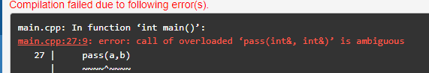

It is showing a ambiguity eror because there is two function named pass with different parameters type one takes int as a parameter and other takes reference to int .For this reason compiler unable to decide.

#include <iostream>

using namespace std;

void test(double x) {

cout << "Double: " << x << endl;

}

void test(float x) {

cout << "float : " << x << endl;

}

int main() {

int x = 5.5;

test(x);

return 0;

}

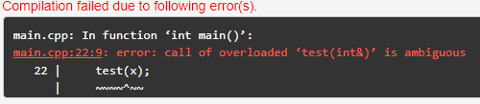

This is the another example of ambiguity eror.Here test function has two different parameters and when in main function we pass the value the test function overloaded and this eror happening we can resolve it by using int function instead of float.